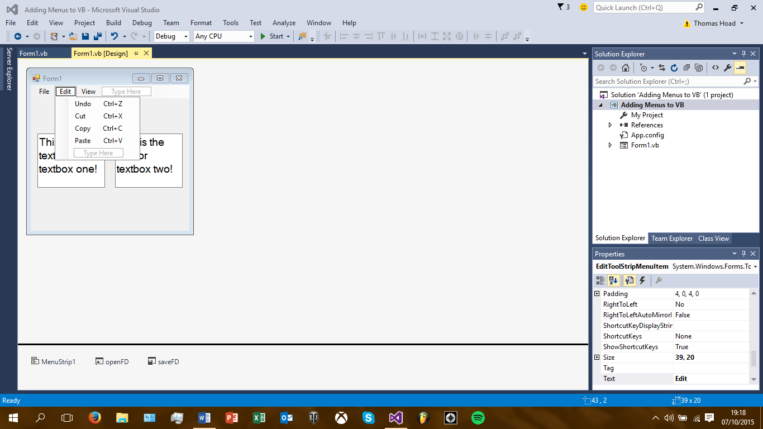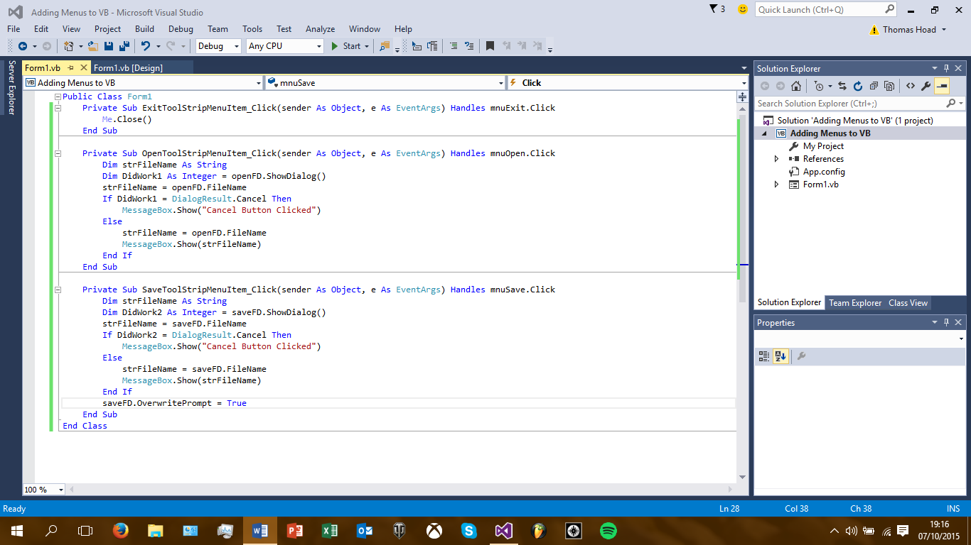Visual Studio Screenshots #5

1. You can add shortcuts to menus to make it more professional.
2. Use an ampersand symbol to get an underlined shortcut.
3. Use an open/save file dialog to open a file or to save your presently used file.
4. Initial Directory – The file location on the PC.
5. Title Property – Change this to show what you are doing (e.g. opening a file)
6. Filter Property – Allows you to identify certain files in your dialog boxes to find files.
7. Overwrite Prompt – Will warn you if you are going to overwrite a previously saved, similarly named file.